**Problem Statement**

You have been asked to:

● Use the previous deployment of ansible cluster

● Configure the files folder in the role with index.html which should be replaced with the original index.html

All of the above should only happen on the slave which has nginx installed using the role

**Solution Approach**

**Step 1: Create and Setup ec2 instances**

* We will create 3 ec2 instance: Master, Slave 1 and Slave 2
* We will set up the connections such that we can ssh from the Master into both Slave 1 and 2

**Step 2: Setting up Master-Slave architecture**

Used the following set of codes to set up master slave architecture between the Master and 2 Slaves

1. which python3 # check if python is installed

2.

3. # Install Ansible only in the master node

4. sudo yum install -y ansible

5.

6. # Create a new user with the name "ansible" in the MASTER node

7. sudo useradd ansible

8. sudo passwd ansible # Generate a password for the user

9. su – ansible # log in to the user

10.

11. # Create a new user with the name "ansible" in the both slave nodes

12. sudo useradd ansible

13. sudo passwd ansible # Generate a password for the user

14. su - ansible

15.

16. # Provide sudo access to the ansible user in the both the slave nodes

17. cd /etc/ # go to folder

18. sudo vi sudoers # open sudoers in a text editor

19. # add this to wheel: ansible ALL=(ALL) NOPASSWD: ALL

20.

21. # Generate a public and private key in the MASTER node

22. su - ansible # log in to the user

23. ssh-keygen # command to generate keypairs

24.

25. # In order to establish the ssh connection, we need the public IP of the Slave nodes

26. curl ifconfig.me

27.

28. # Run this in SLAVE node to enable ssh port

29. cd /etc/ssh # go to ssh folder

30. sudo vi sshd_config # the file sshd_config has details that needs to be changed

31. # Search for the setting "PasswordAuthentication" and change the setting from "no" to "yes"

32. sudo systemctl restart sshd # restart sshd service

33.

34. # Now try gaining remote access to both servers from Master

35. ssh ansible@3.111.149.212 # Slave 1

36. ssh ansible@ 65.0.122.233 # Slave 2

37.

38. # Copy public key from master to remote server

39. ssh-copy-id ansible@{slave public ip}

**Step 3: Creating ansible configuration and inventory file**

1. Creating the configuration file as follows:

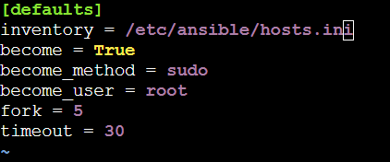

1. Creating the inventory file as follows:

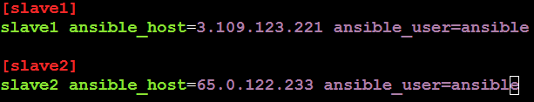

**Step 4: Creating the Ansible Roles**

The 2 Ansible Roles will be created as required in the question

1. sudo ansible-galaxy init /etc/ansible/roles/role1 # creating role 1 for apache

2. sudo ansible-galaxy init /etc/ansible/roles/role2 # creating role 2 for nginx

This is what the directory structure looks like after creating the roles

ansible-roles/

├── inventory

├── site.yml

├── roles/

│ ├── apache2/

│ │ ├── tasks/

│ │ │ └── main.yml

│ │ └── defaults/

│ │ └── main.yml

│ ├── nginx/

│ ├── tasks/

│ │ └── main.yml

│ └── defaults/

│ └── main.yml

**Step 5: Creating a custom index.html**

As required in the question, we create a custom *index.html* in *roles/role2/files.*

1. <!DOCTYPE html>

2. <html lang="en">

3. <head>

4. <meta charset="UTF-8">

5. <meta name="viewport" content="width=device-width, initial-scale=1.0">

6. <title>Welcome to Custom Nginx</title>

7. </head>

8. <body>

9. <h1>This is the custom index.html served by Nginx.</h1>

10. </body>

11. </html>

12.

This file needs to be copied to the slave server

**Step 6: Updating the main.yml files in Role2 to include the copy index.html step**

1. The *main.yml* file in role2:

Here, we add the copy index.html step as required in this question

1. ---

2. - name: Install Nginx

3. apt:

4. name: nginx

5. state: present

6. become: yes

7. - name: Replace the default index.html with a custom file

8. become: yes

9. copy:

10. src: index.html

11. dest: /usr/share/nginx/html/index.html

**Step 7: Creating the Ansible Playbook with the New Roles Defined**

This is the ansible playbook that will be triggered.

1. ---

2. - name: Install Apache2 on slave1

3. hosts: slave1

4. roles:

5. - role1

6.

7. - name: Install Nginx on slave2

8. hosts: slave2

9. roles:

10. - role2

**Step 8: Executing the Ansible Playbook**

The ansible playbook was executed using the below commands:

1. ansible-playbook playbook_role.yml --syntax-check   # code to check for syntax error

2. ansible-playbook playbook_role.yml --check          # dry run on terminal

3. ansible-playbook playbook_role.yml                  # final run on the server

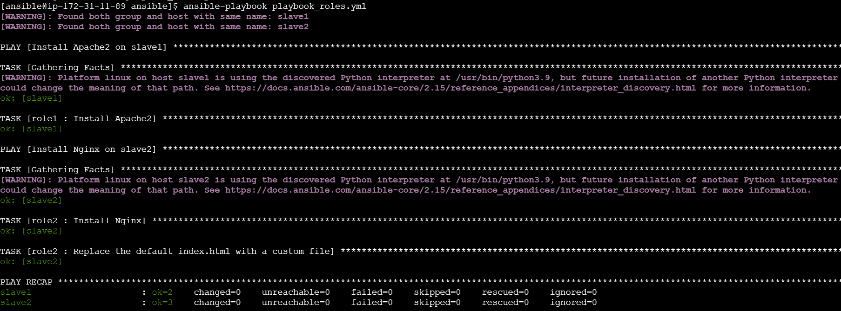

**Step 9: Checking if the index.html file is copied to the slave server**

Slave 2:

